7. React-JS HOL

Name:- Shubham Sangram Bej

Hands-on 7

Objective
- Understand React Props.
- Pass data from a parent component to a child component using Props.
- Display dynamic data in a tabular format.

Software Requirements
- Node.js
- npm
- React
- Visual Studio Code

Project Name
shoppingapp

Procedure
- Created a new React application named shoppingapp.
- Created a class component named Cart.
- Defined two properties:
  - Item Name
  - Price
- Used Props to receive an array of shopping items from the parent component.
- Created another class component named OnlineShopping.
- Initialized an array of five shopping items.
- Passed the array to the Cart component using Props.
- Displayed all shopping items inside an HTML table.
- Applied CSS styling to center the table and display headings in dark green and item details in green.
- Executed the application using:
npm start
- Verified the browser output.

Output
The application successfully displays all ordered shopping items in a bordered table. The heading is displayed in dark green while the table contents are displayed in green.
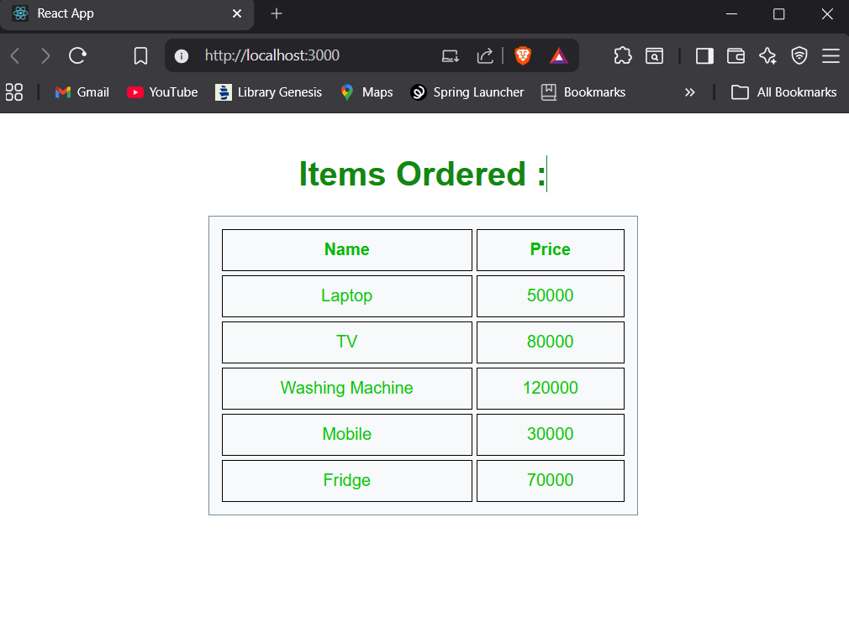

Result
The React application shoppingapp was successfully developed. Props were used successfully to transfer data between components and display it in a tabular format.

